1)API connection between Jenkins and GitHub repo
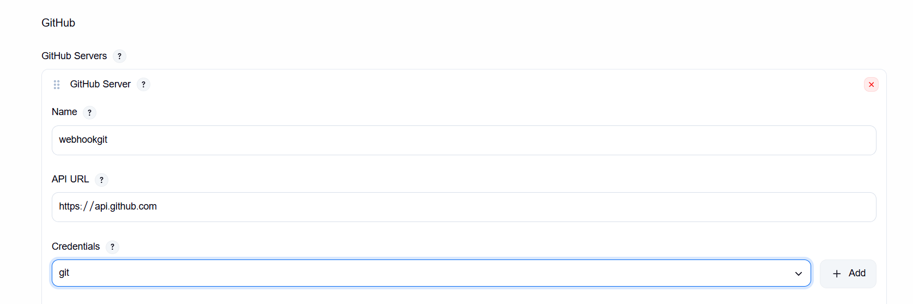
2)three jobs with configuration
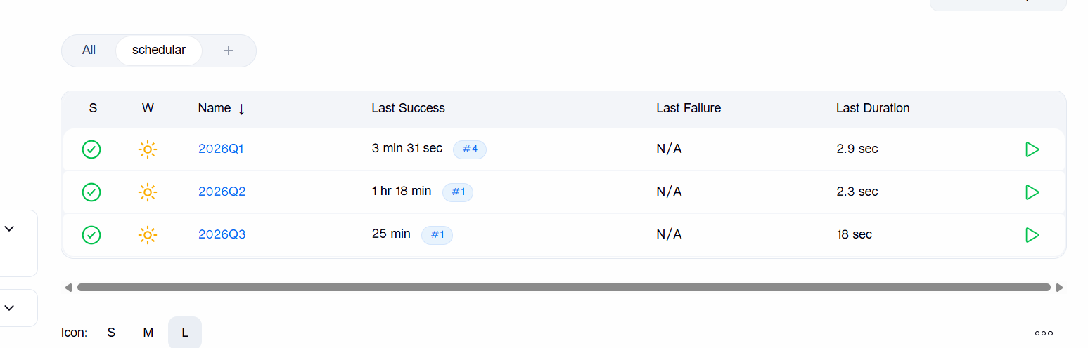

- 2026Q1

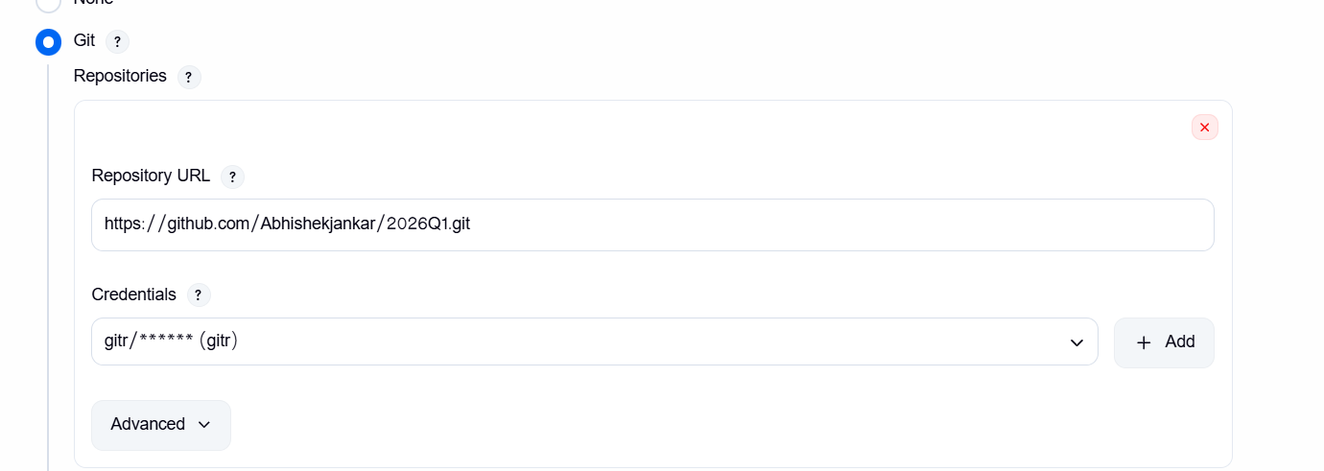

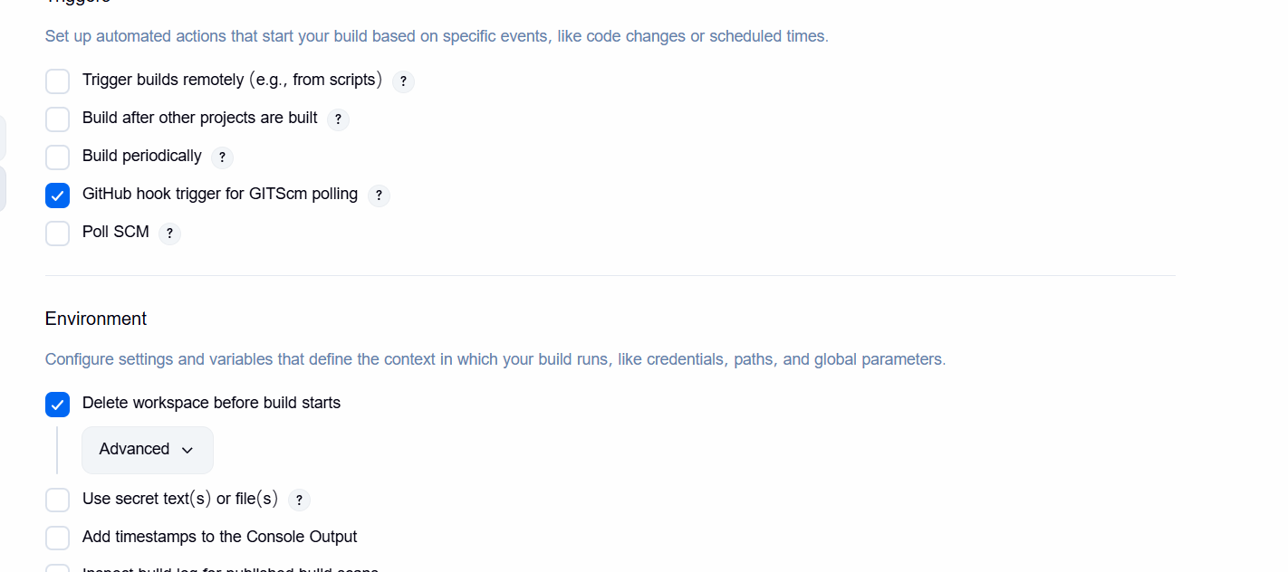

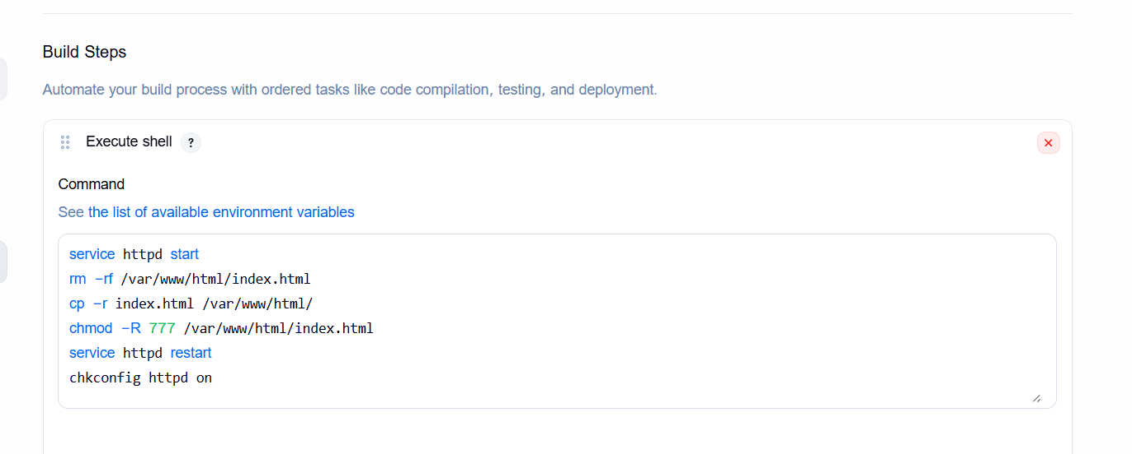
service httpd start
rm -rf /var/www/html/index.html
cp -r index.html /var/www/html/
chmod -R 777 /var/www/html/index.html
service httpd restart
chkconfig httpd on
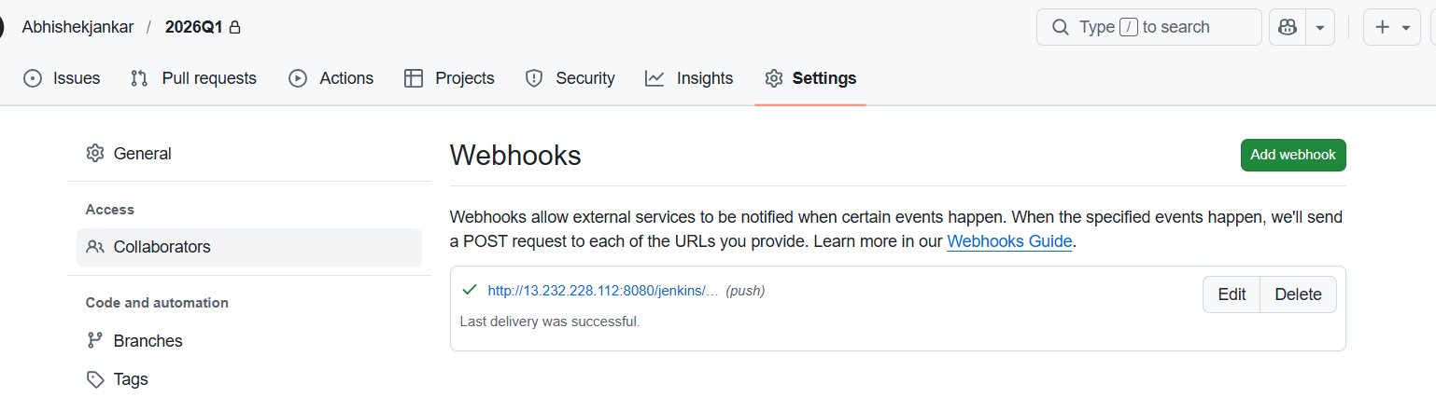

- 2026Q2

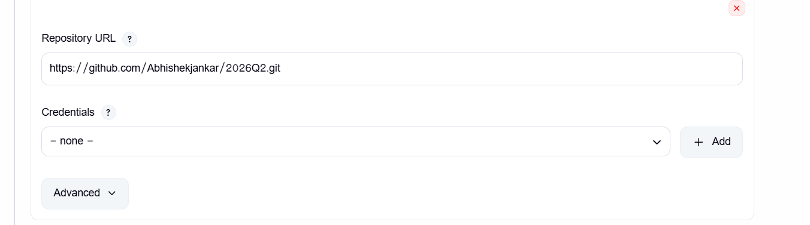

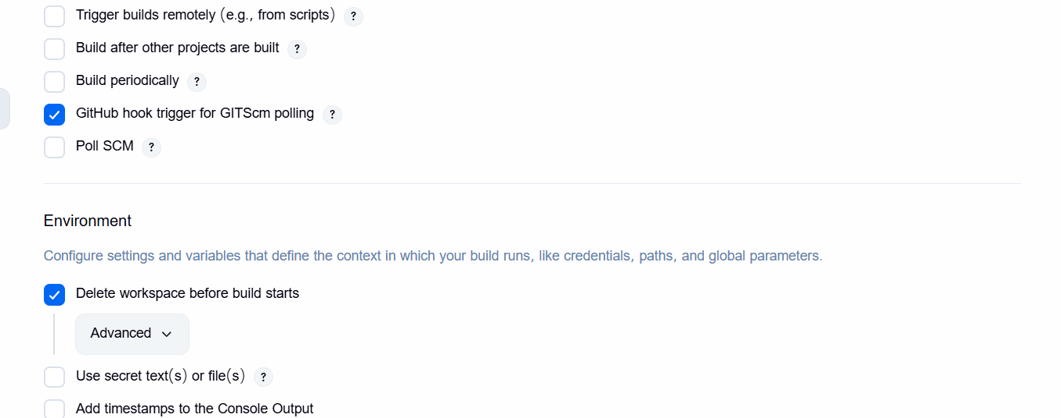

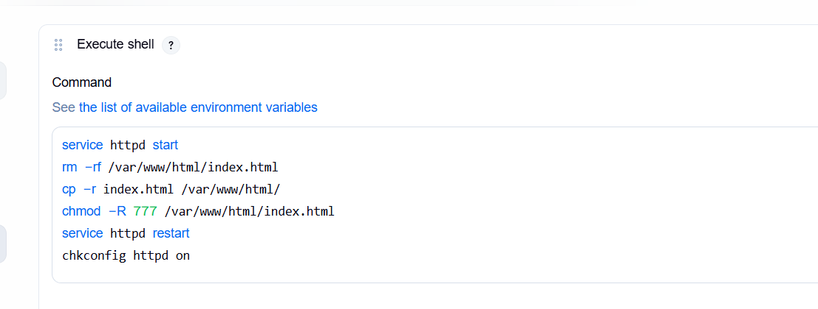
service httpd start
rm -rf /var/www/html/index.html
cp -r index.html /var/www/html/
chmod -R 777 /var/www/html/index.html
service httpd restart
chkconfig httpd on

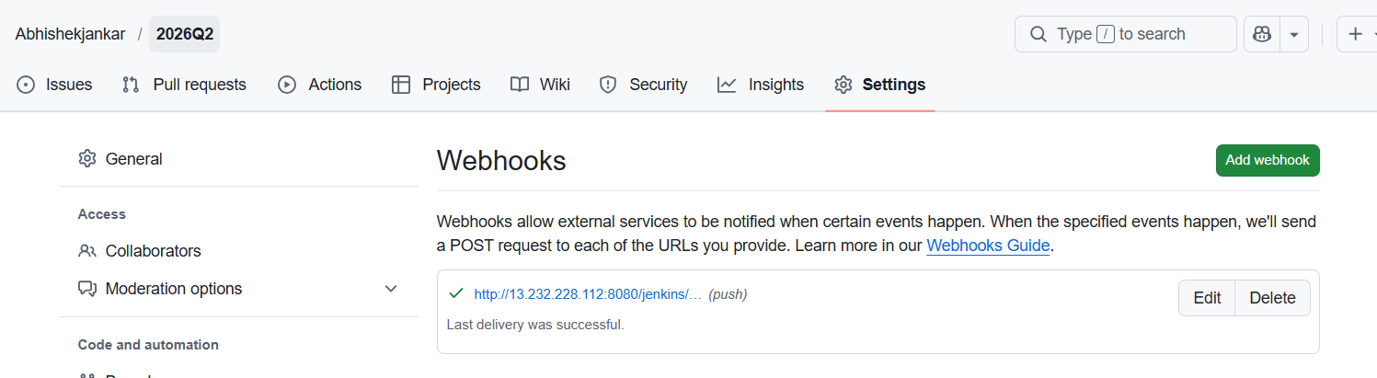

- 2026Q3

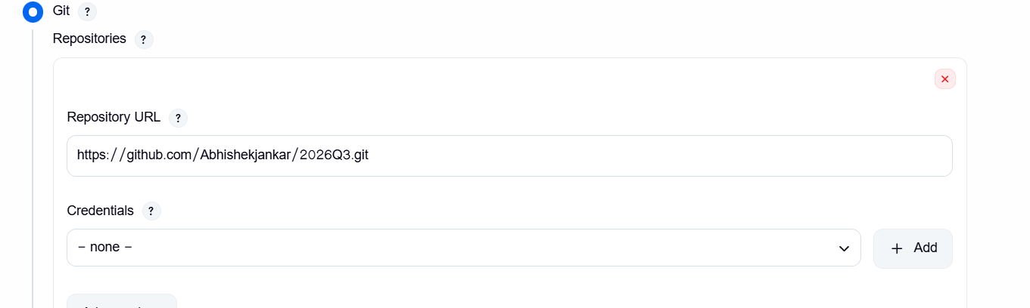

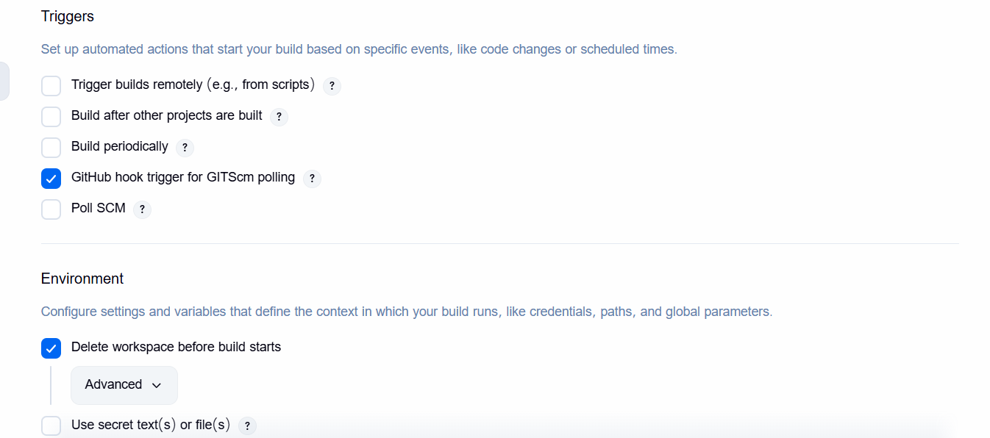

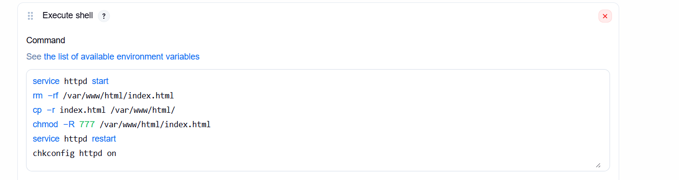
service httpd start
rm -rf /var/www/html/index.html
cp -r index.html /var/www/html/
chmod -R 777 /var/www/html/index.html
service httpd restart
chkconfig httpd on

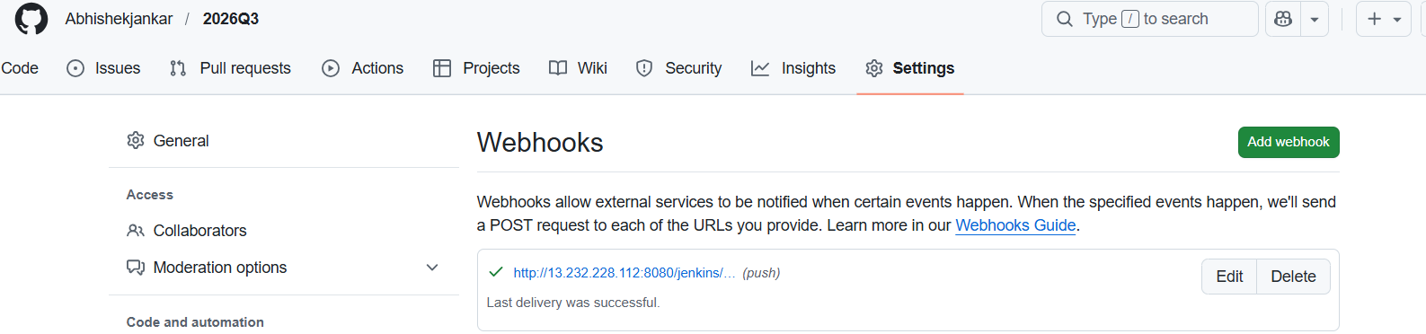

- When I change in 2026Q1

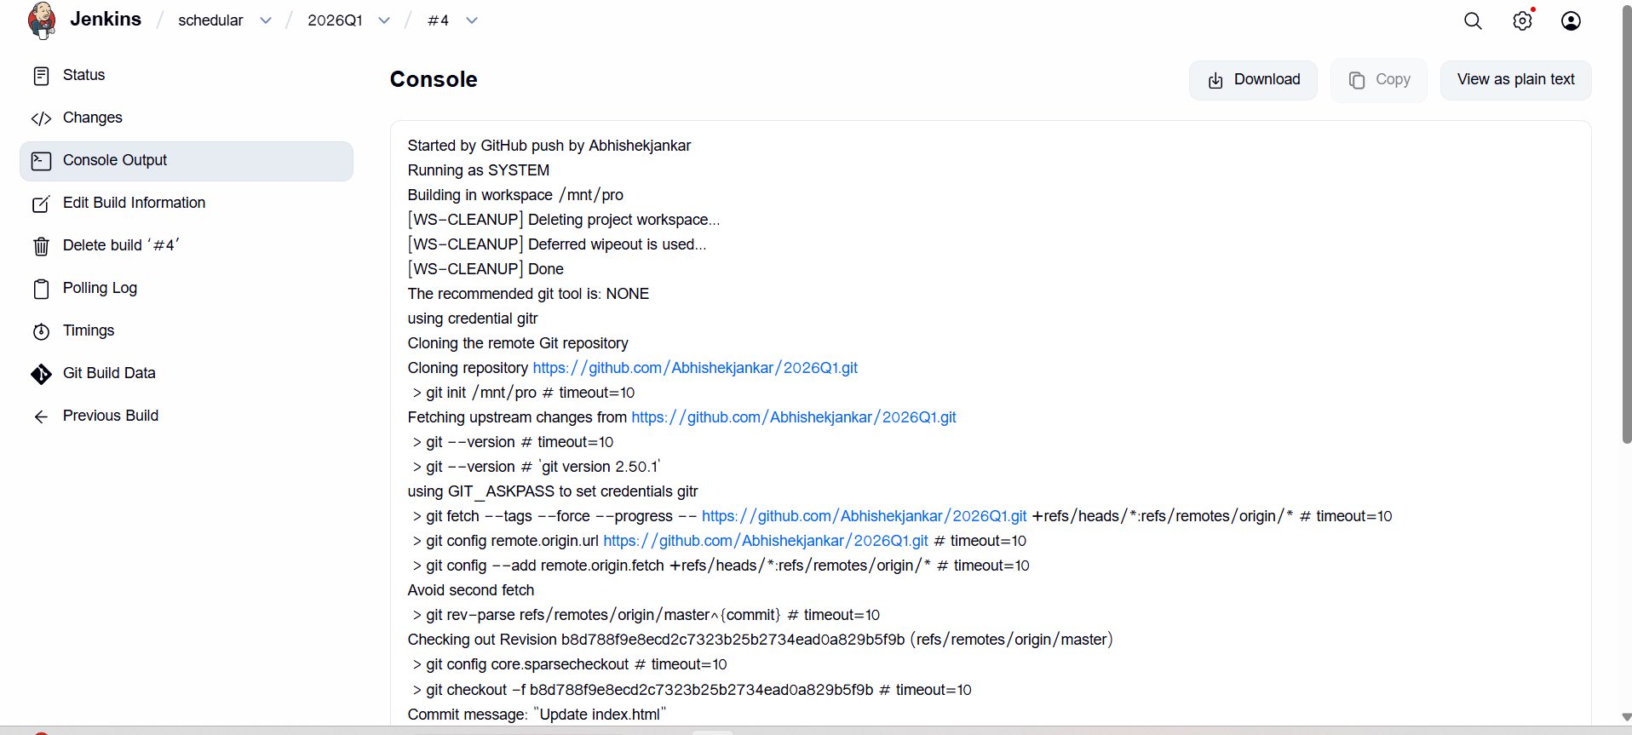
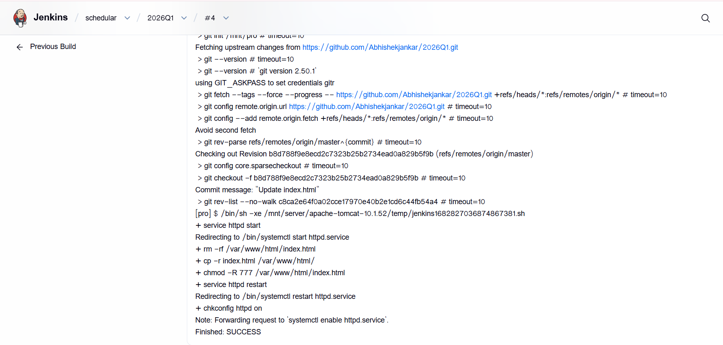

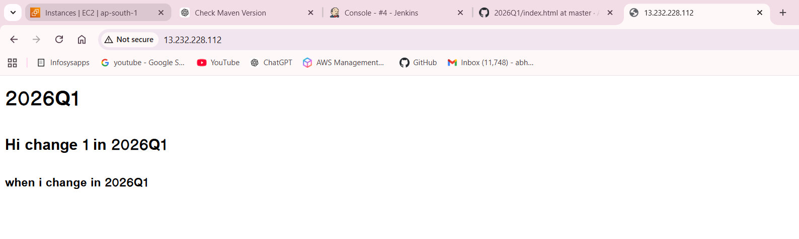

- When I change in 2026Q2

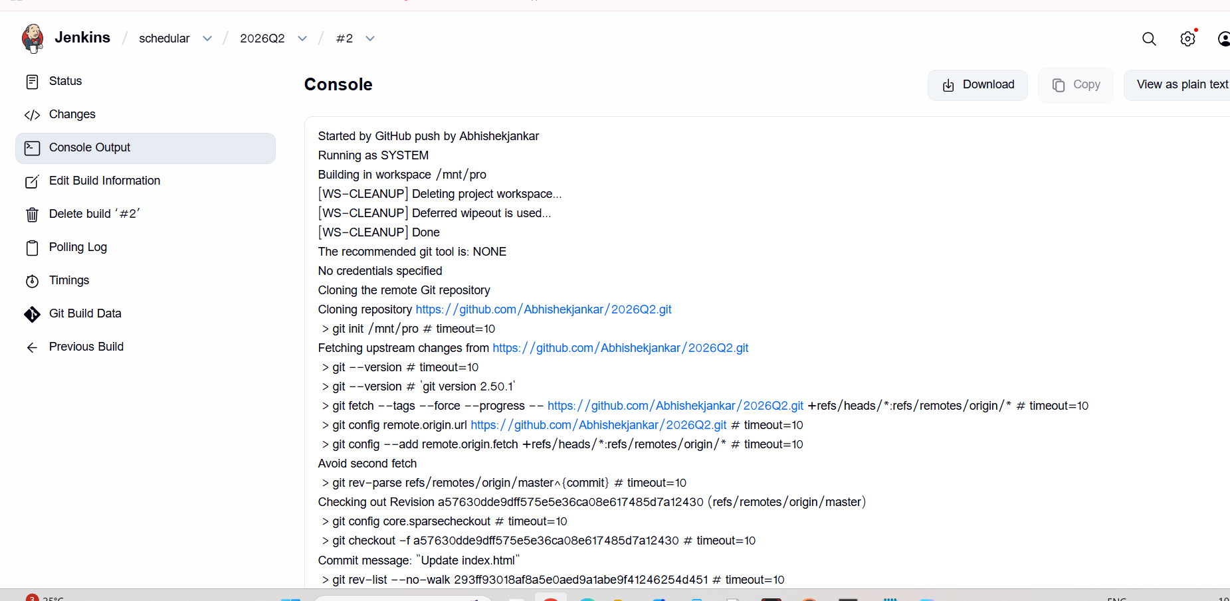
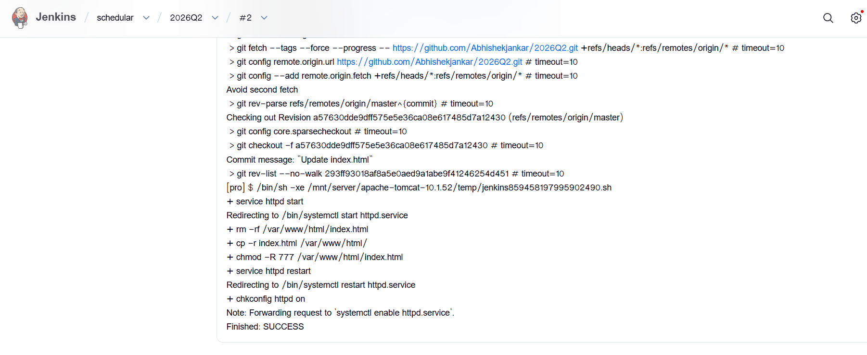

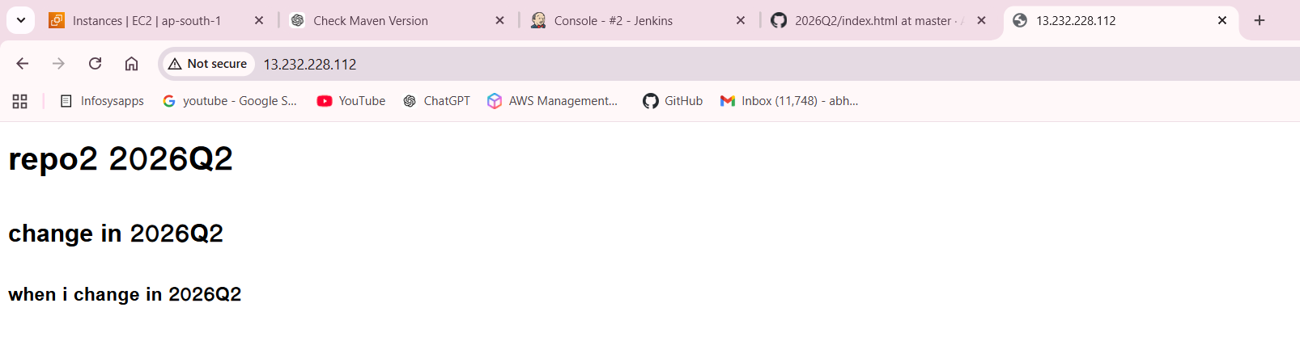

- When I change in 2026Q3

